**Some Tips for POM Automation**

# **Login EP with user have another role/org**

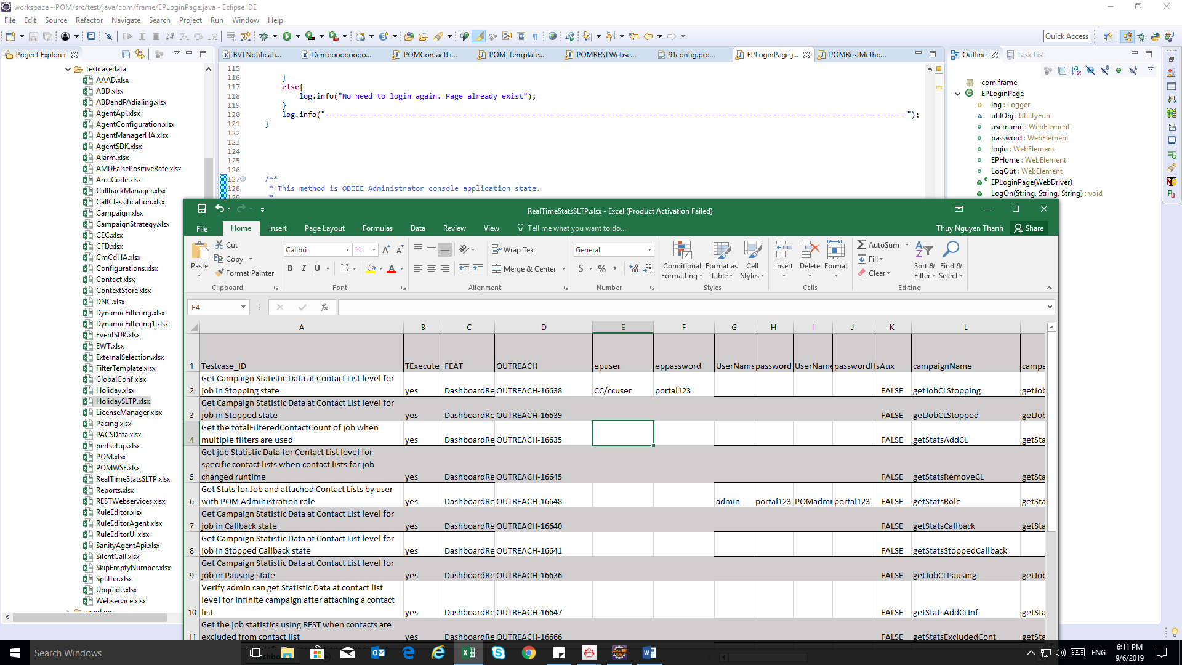Add 2 columns “epuser” and “eppassword” in datatestcase. Then provide info of user into these columns.

# **Send rest web service with user have another role/org**

Add 2 lines as below for put new info of user before run rest web service command.

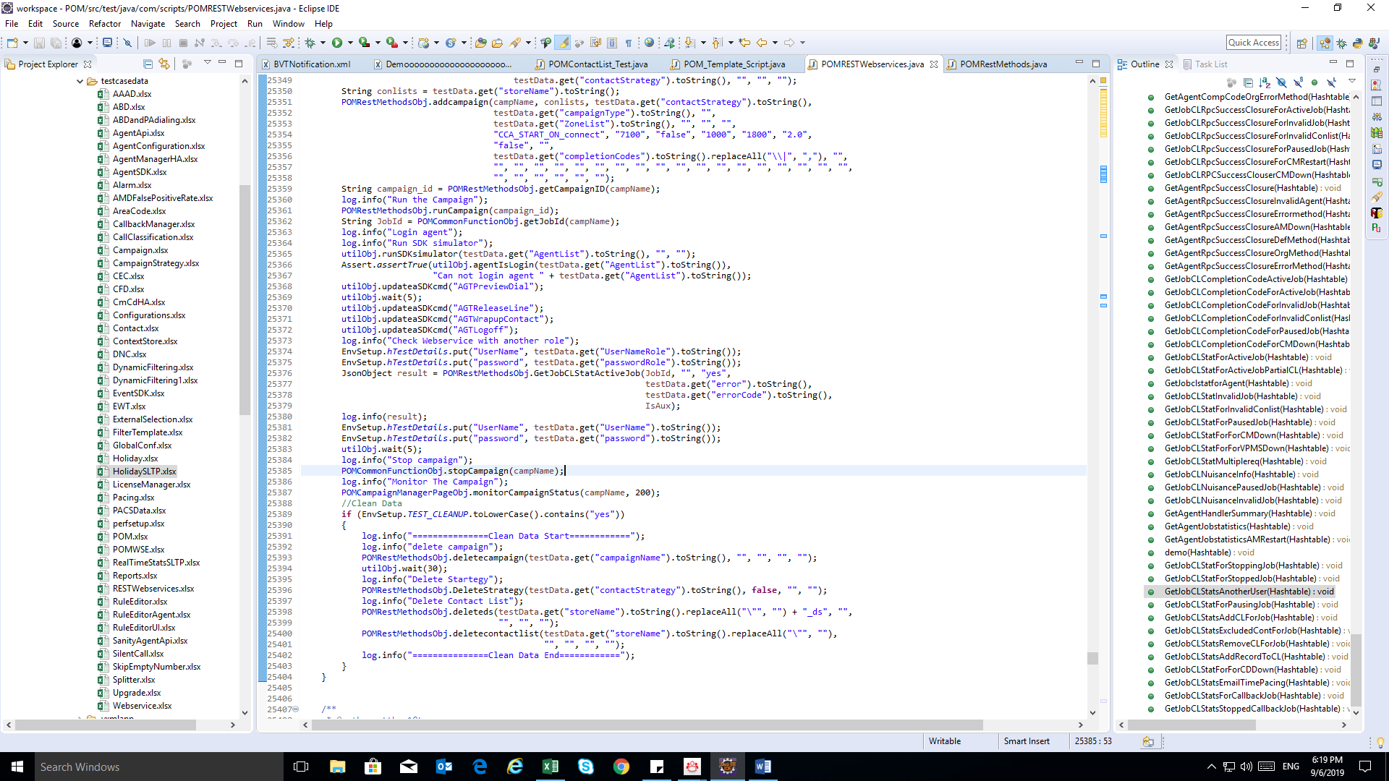Then **remember** **put** **info of default user** **again**.

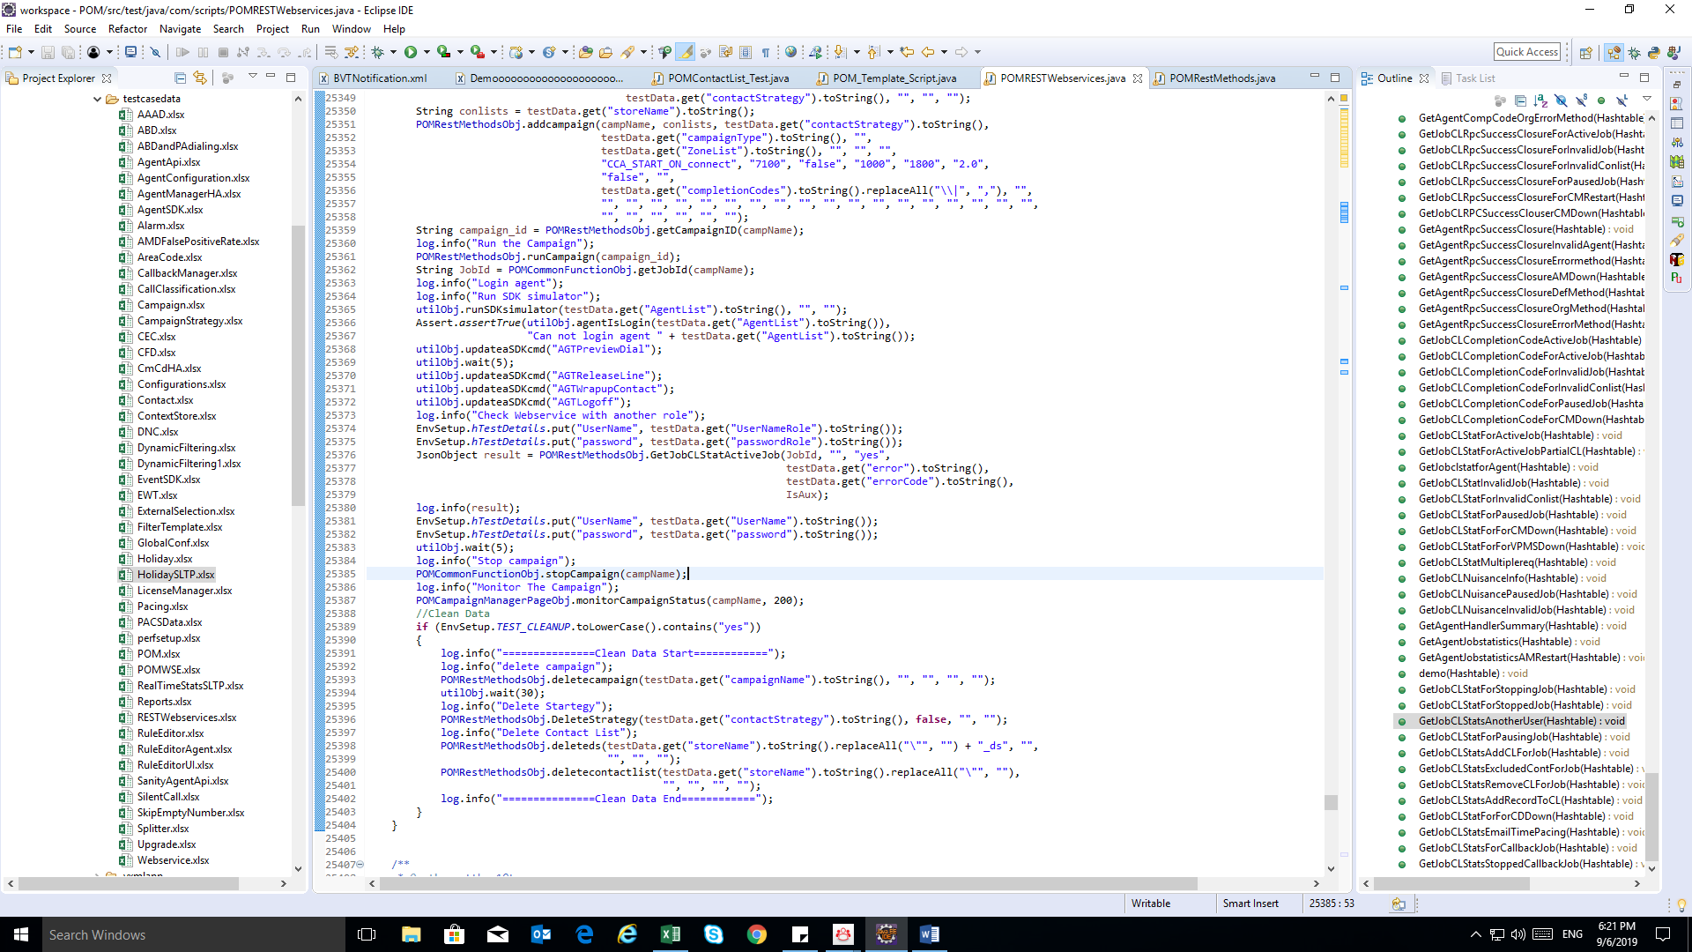Ex:

# **Install OpenSSH for windows**

Link: <https://o7planning.org/vi/11409/cai-dat-openssh-server-tren-windows>

**Note**: should use OpenSSH v0.0.10.0

# **Unable to locate element**

**Unable to locate element**: {"method":"xpath" "selector":"(//input[@id Snapshot : Super admin should be able to update schedule for all orgs_09-30-2019_11.12.23.png

(This error means cannot find element)

**Tips:**

1. **Check xpath/css/… in page is existing or not?**
2. Check zone is turn on or not? (should turn on zone).
3. For delay time: should expand time (in code) or run again with phantomjs.